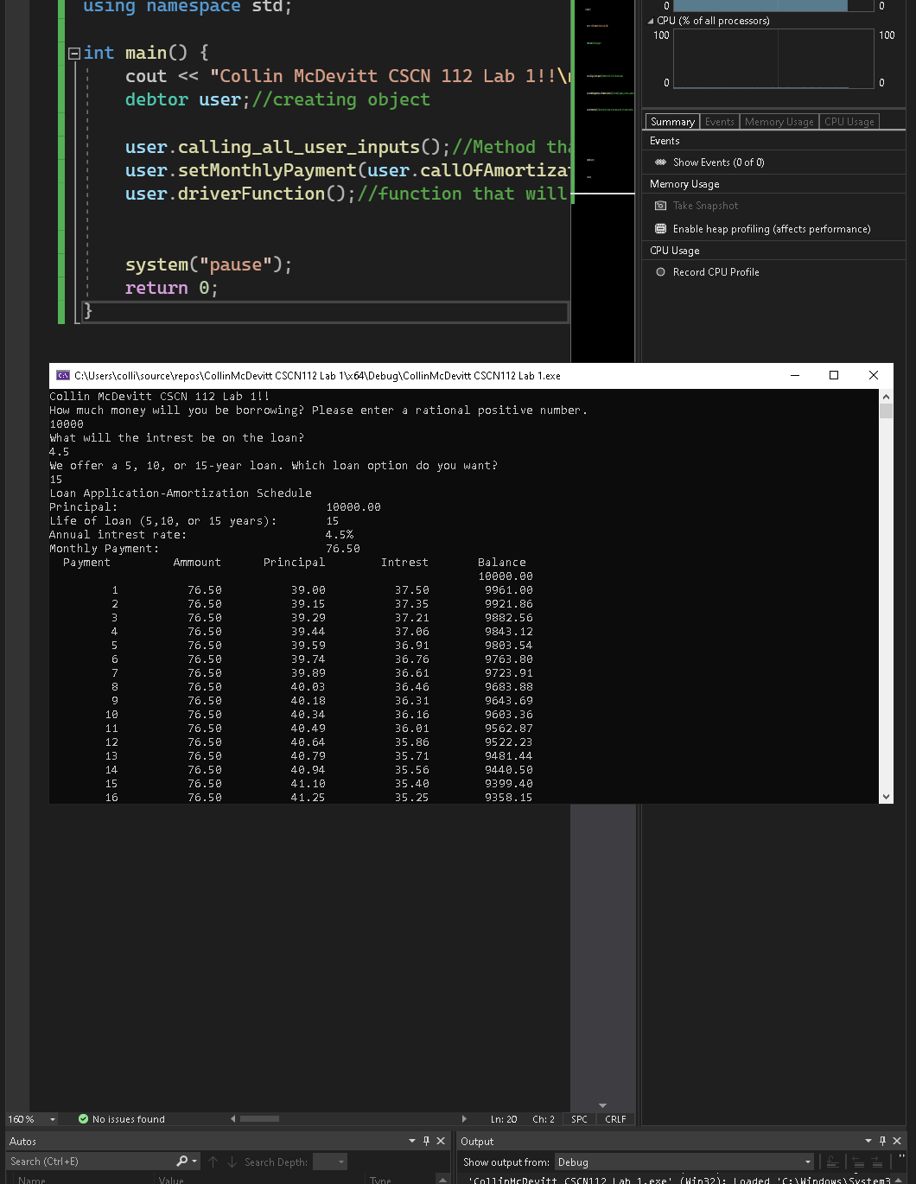

I have not shared the source code in my program with anyone other than my instructor’s approved human sources.

⦁ I have not used source code obtained from another student, or any other unauthorized source, either modified or unmodified.

⦁ If any source code or documentation used in my program was obtained from another source, such as a text book or course notes, that has been clearly noted with a proper citation in the comments of my program.

⦁ I have not knowingly designed this program in such a way as to defeat or interfere with the normal operation of any machine it is graded on or to produce apparently correct results when in fact it does not.

Algorithm

In main create an object

Call the method that will call the user inputs and store and error check and store those inputs in the member variable of the object.

Call the method that sets the monthly payment and in that monthly payment as a parameter call the amortization calculator

Call the method that has the recursive function it which formats the output to the terminal and also outputs to a .csv file so it can also be opened in excel